**QUIC Spin Bit implementation and Analysis**

Abstract

**QUIC** is a secure general-purpose, encrypted, multiplexed, and low-latency transport protocol designed from the ground up to improve transport performance for HTTPS traffic. QUIC has recently (May 2021) became RFC standard (RFC 9000) and is expected to become the dominant transport protocol in the Internet over TCP. Most of QUIC packets are encrypted. Not only the payload is encrypted but also most of the header. This situation makes it very difficult for the ISP (Internet Service Provider) to monitor the network and enforce regulatory measures to keep the network up and running. One important parameter for ISPs to monitor network health is RTT estimation. When RTT rise too high for many flows it may indicate that queues build-up and an up-coming network collapse. In such situations the ISP may limit heavy users and keep the network alive. Therefore, an efficient estimation of RTT is an important network management. As QUIC is almost fully encrypted, there are only few unencrypted bits, one of them is the Latency SPIN Bit which was added to the protocol especially for RTT estimation.

Latency SPIN Bit operation:

* When a server sends a packet, it sets the spin bit to the spin bit on the last packet it received from the client.
* When a client sends a packet, it sets the spin bit to the inverse of the spin bit on the last packet it received from the server.

Therefore, the SPIN bit has an **edge** (transition from “1” to “0’ or from “0” to “1”) every RTT and an observer can estimate the RTT by measuring the time between edges of a connection.

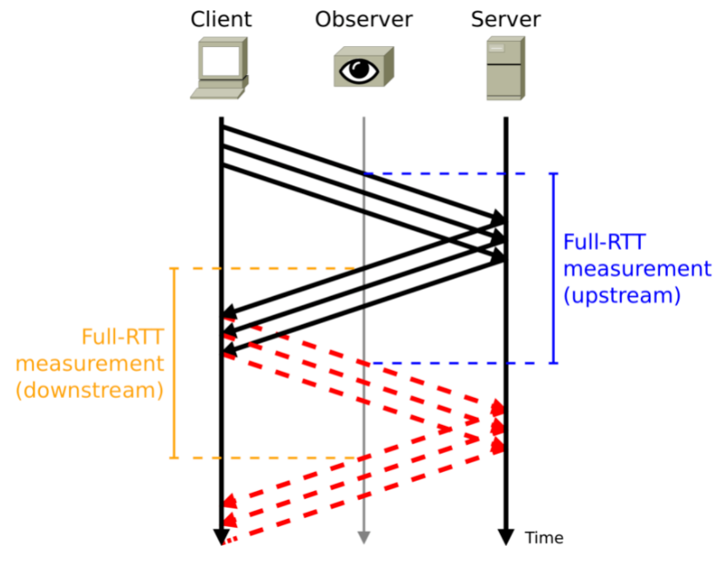

Figure1: Latency SPIN bit operation

Problem

It is hard for a middle box observer to estimate the Round Trip Time of a QUIC connection.

Project objective

Set a middle box observer that estimates the RTT of connections using a Latency SPIN bit.

# Project overview

1. Define a method to identify a QUIC connection by its wire image.  
   See ref [1], [2].
2. Analyze Wireshark/Pyshark QUIC filter and determine how they identify a QUIC connection.
3. Modify Pyshark to comply with [2] if necessary.
4. Compare two publically available QUIC implementations: aioquic, lsquic and install one them on a lab station. (You may suggest another implementation)
5. Install two QUIC debug tools: qlog, qviz.
6. Initiate a client-server application that uses QUIC as the transport layer and enable the SPIN bit.
7. Code a script that monitors the communication and estimates RTT by measuring delay between SPIN bit edges.
8. Validate your solution by setting a network emulation tool to emulate different RTTs.

# Notes

* The above list is an estimate. Goals and tasks may be modified during the first few weeks of the projects before the finalization of High Level Design Document.
* General requirements for all LCCN Projects are specified at the lab website: <https://lccn.cs.technion.ac.il/lab-courses/>

# Prerequisites:

1. Introduction to computer networks (236334) - Mandatory
2. Internet Networking (236341) – Nice to have

Instructor: Eran Tavor ([tavran@cs.technion.ac.il](mailto:tavran@cs.technion.ac.il))

# **References**

1. **QUIC: A UDP-Based Multiplexed and Secure Transport** <https://datatracker.ietf.org/doc/html/rfc9000>
2. **Manageability of the QUIC Transport Protocol** <https://datatracker.ietf.org/doc/html/draft-ietf-quic-manageability-13>

# **Appendix A: QUIC ramp-up**

1. Short introductory  
   <https://www.youtube.com/watch?v=y8xHJJWwJt4>
2. Another intro video  
    <https://www.youtube.com/watch?v=HnDsMehSSY4>
3. A more deep diving introductory  
   <https://youtu.be/9Lany3ApvjM>
4. A thorough tutorial  
   <https://www.youtube.com/watch?v=CtsBawwGwns&t=89s>
5. And of course [1] and [2] above.